

**Faculty of engineering - Shoubra**

**Benha University**

# Research Article / Research Project / Literature Review

in fulfillment of the requirements of

|  |  |
| --- | --- |
| **Department** | **Engineering Mathematics and Physics** |
| **Division** | **---------------------------** |
| **Academic Year** | **2019-2020** |
| **Course name** | **COMPUTER** |
| **Course code** | **ECE001** |

## Title: -

**Artificial intelligence**

By:

|  |  |  |  |
| --- | --- | --- | --- |
|  | Name | Edu mail | B.N |
| 1 | **احمد محمد إبراهيم محمد** | **AHMED195114@FENG.BU.EDU.EG** | **110** |

**Approved by:**

|  |  |
| --- | --- |
| Examiners committee | Signature |
| |  | | --- | | 1. Dr.Ahmed Bayoumi | |  |
| |  | | --- | | 1. Dr.Shady Elmashad | |  |
| |  | | --- | | 1. Dr. Abdelhamid Attaby | |  |
|  |  |

Name/ احمد محمد إبراهيم محمد

Code/ECE001

B-N/ 110

TOPIC/ ARTIFICIAL INTELLIGENCE

Gethub.Link/file:///C:/Users/Ahmad/OneDrive/Desktop/html.project/mainpage.html

Gethub page: <https://ahmed195114.github.io/html.project-/>

APPLICATION BRIEF/

SCREENSHOTS/

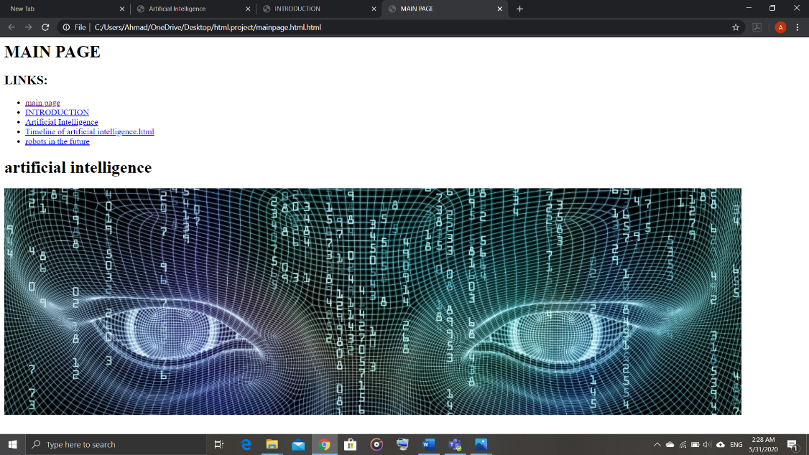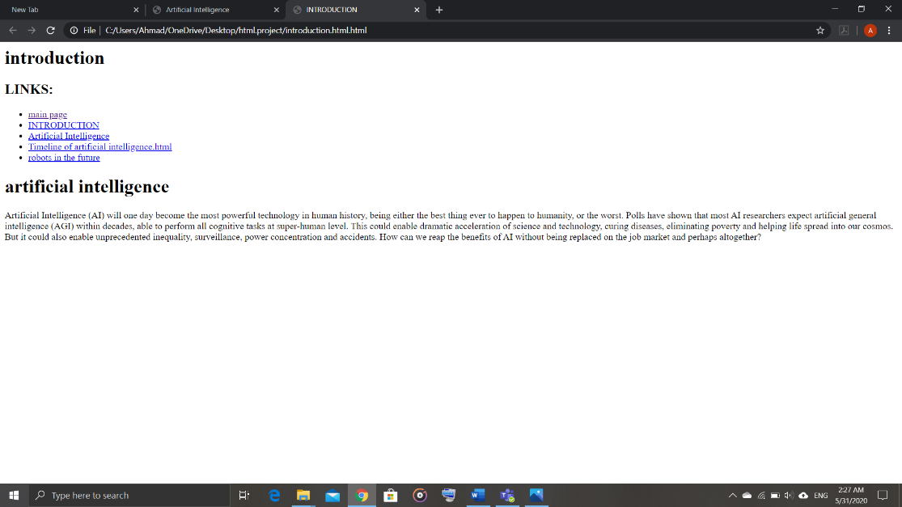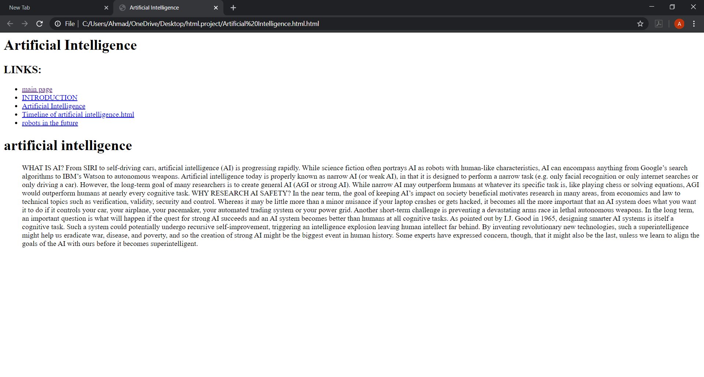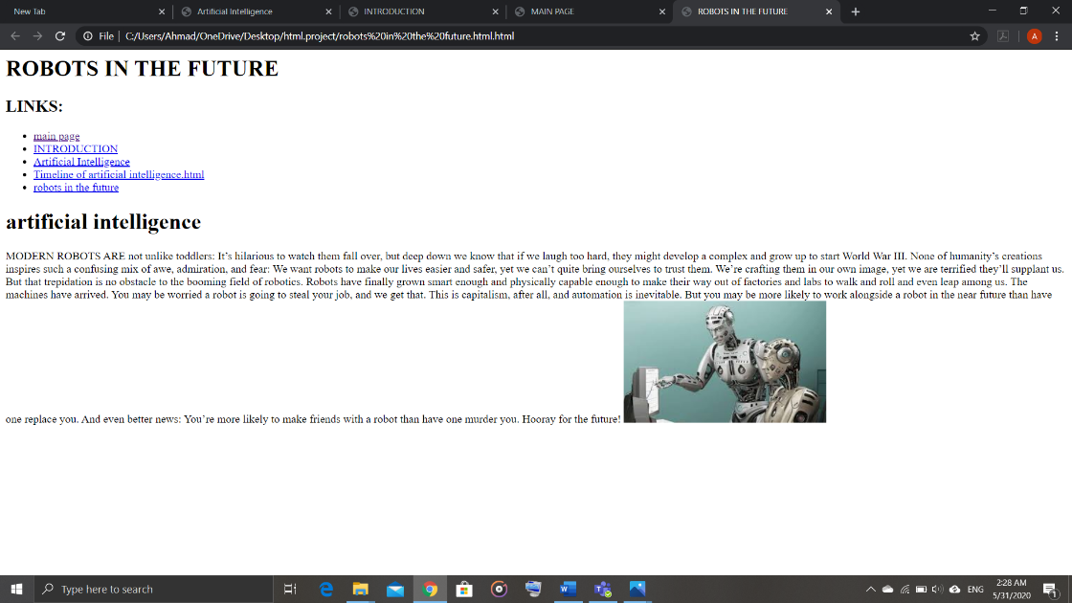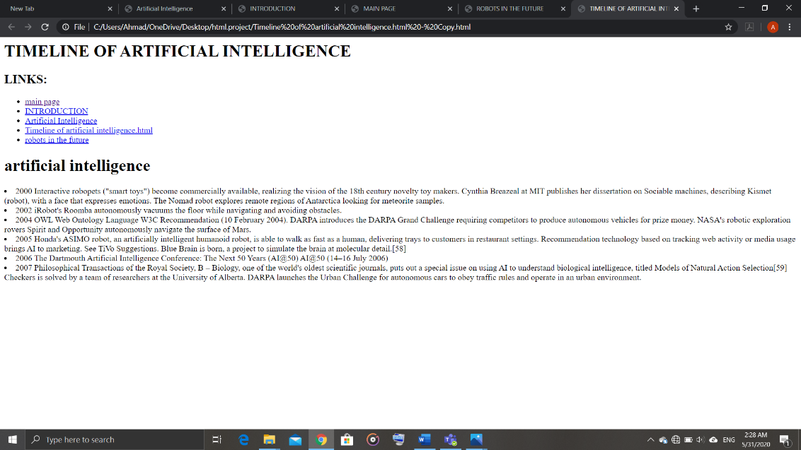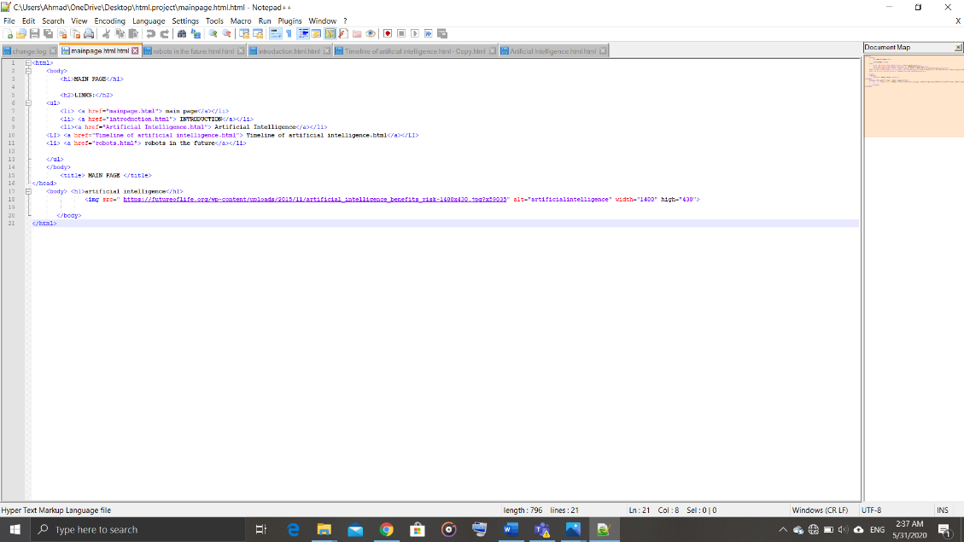

file:///C:/Users/Ahmad/OneDrive/Desktop/html.project/mainpage.html